Monitoring Task

1.Enable CloudTrail monitoring and store the events in S3 and CloudWatch log events.

TITLE:
Storing log events

OBJECTIVE:
To enable CloudTrail logging and store events in S3 and CloudWatch for monitoring.

PREREQUISITES:
IAM Role/permissions
S3 Bucket
CloudWatch Log Group

STEP-BY-STEP-IMPLIMENTATION:
Create a trail
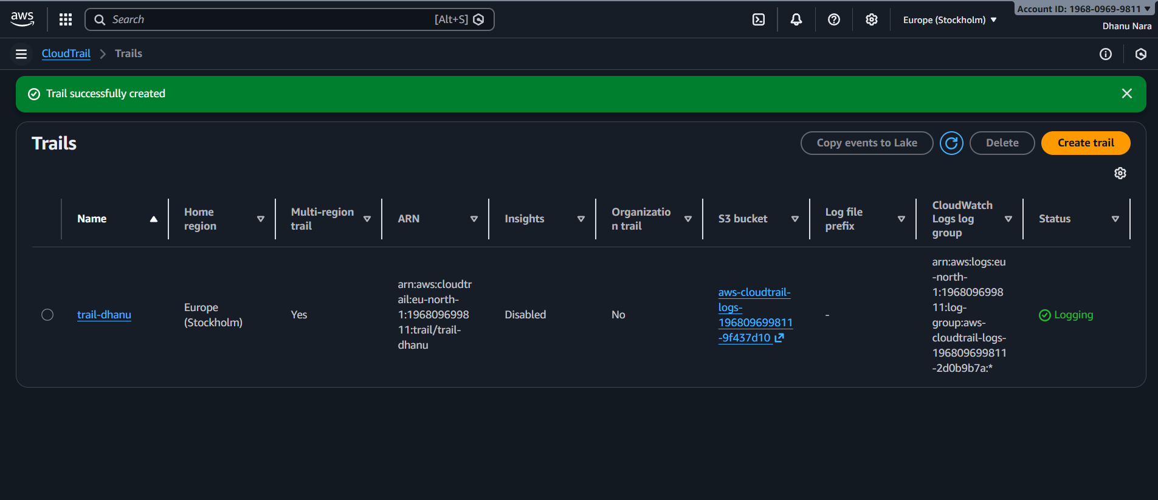

Stored the logs in S3 Bucket
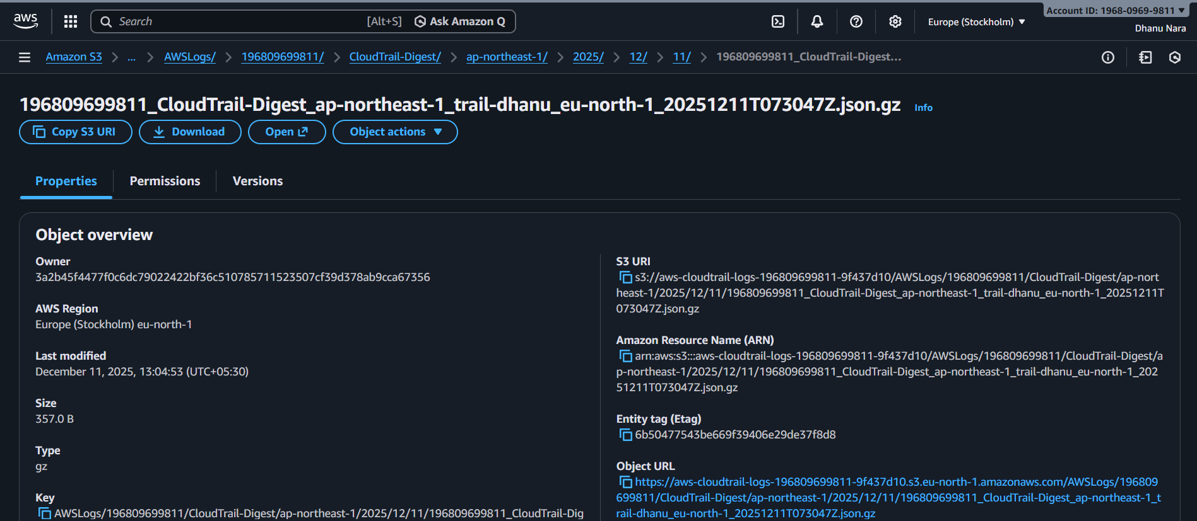
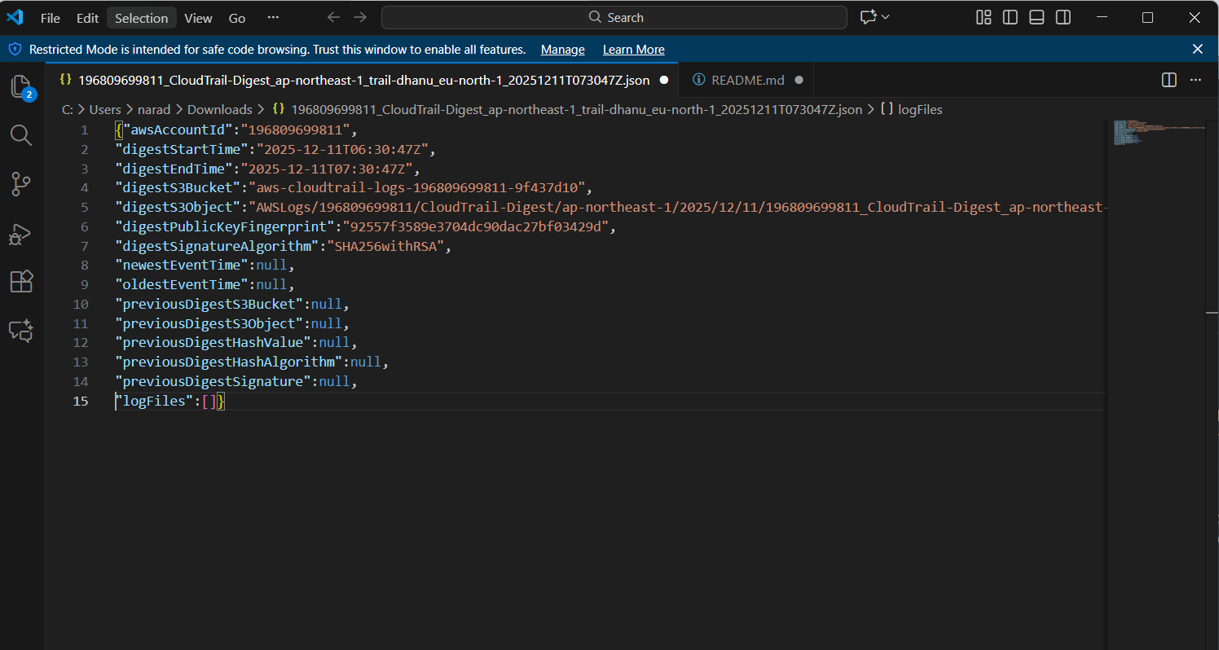
Stored the logs in CloudWatch Log group.
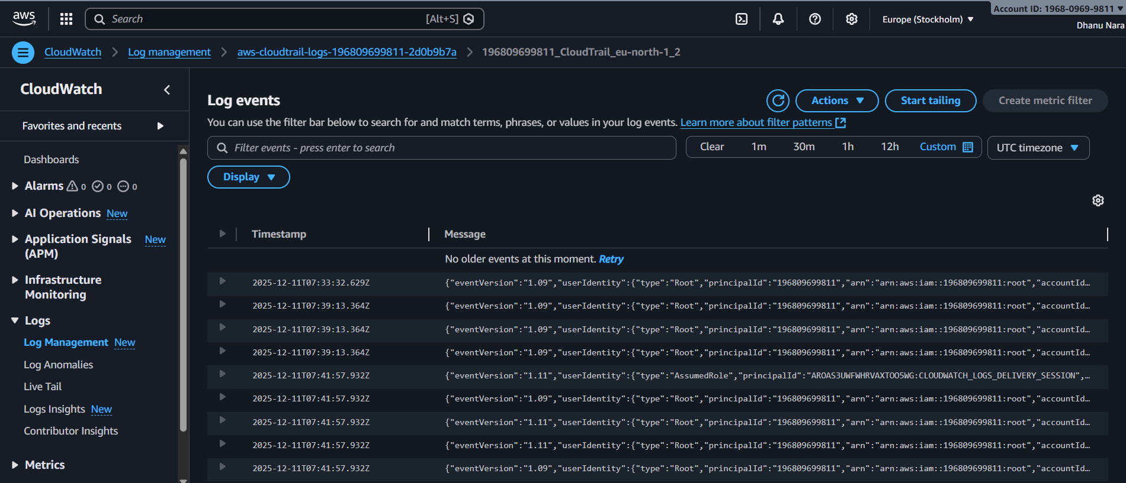

CONCLUSION:
CloudTrail successfully tracks AWS activity and logs them into S3 and CloudWatch for audit and analysis.

2.Enable SNS for CloudTrail to send alert on email.

TITLE:
SNS for CloudTrail

OBJECTIVE:
Send CloudTrail alerts to email using SNS.

PREREQUISITES:
SNS Topic
Email Subscription confirmed
STEP-BY-STEP-IMPLIMENTATION:
Created a subscription.
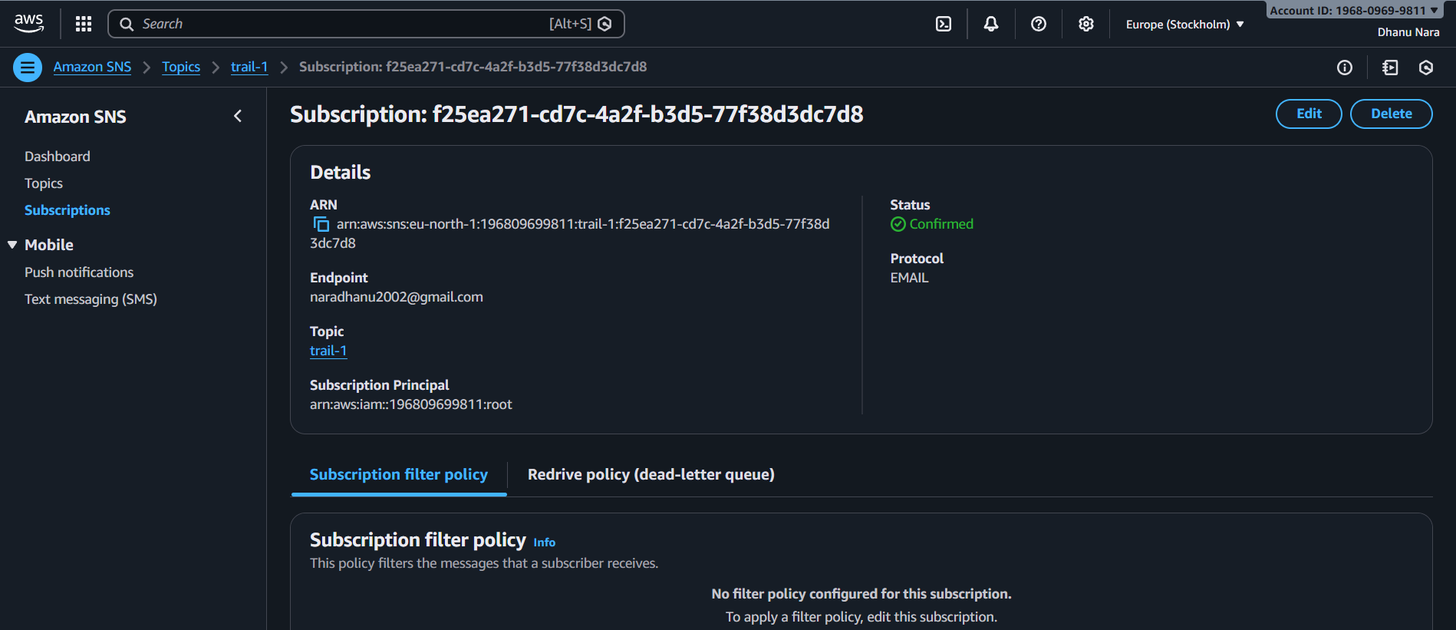
Mail regarding CloudTrail.

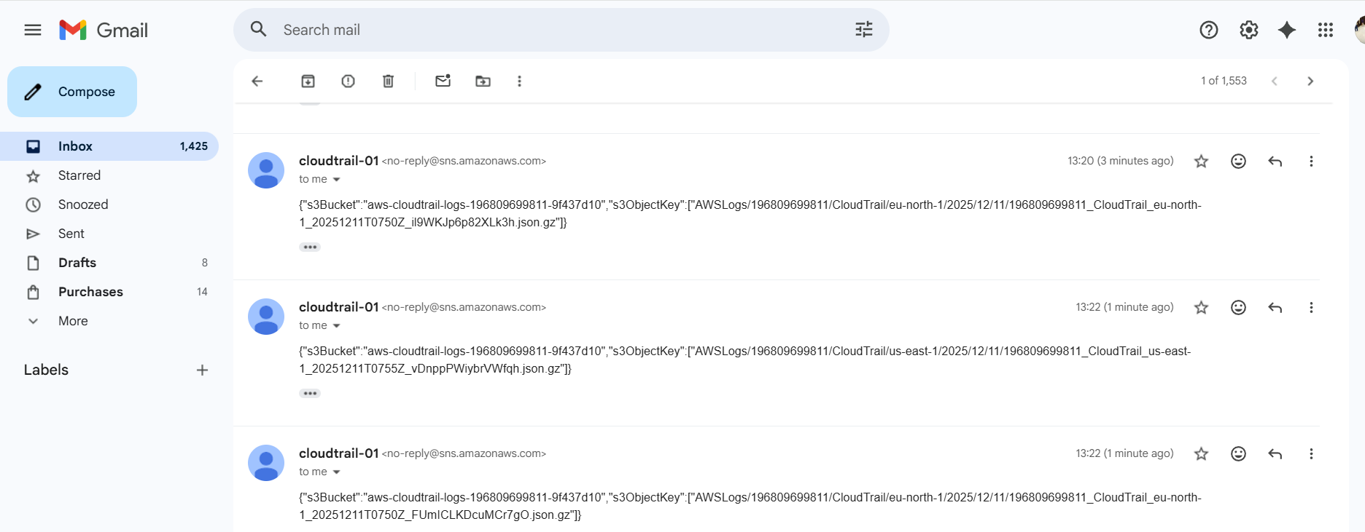

CONCLUSION:
SNS email alerts will now trigger whenever CloudTrail detects specified activity.

3. Configure CloudWatch monitoring and record the CPU utilization and other metrics of EC2.

TITLE:
Monitoring EC2 Metrics

OBJECTIVE:
To monitor and record EC2 instance CPU utilization and other performance metrics using CloudWatch.

PREREQUISITES:
EC2 instance running
IAM Role with CloudWatch permissions

STEP-BY-STEP-IMPLIMENTATION:
I have cretaed dummy info inside EC2 to increase the load.
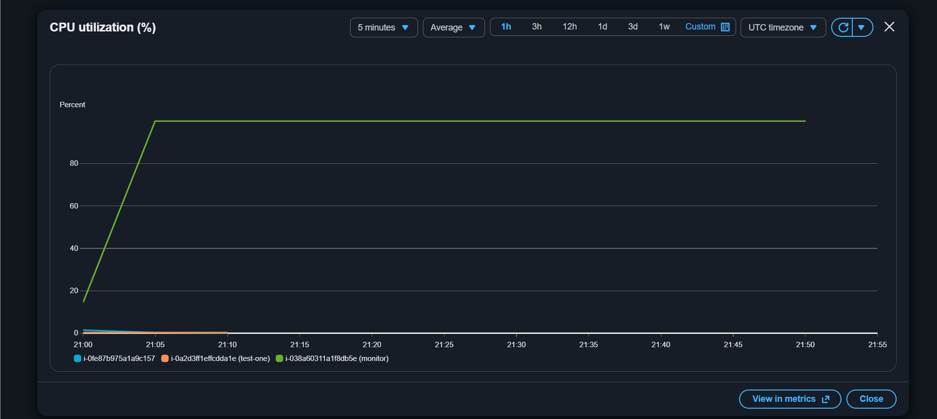

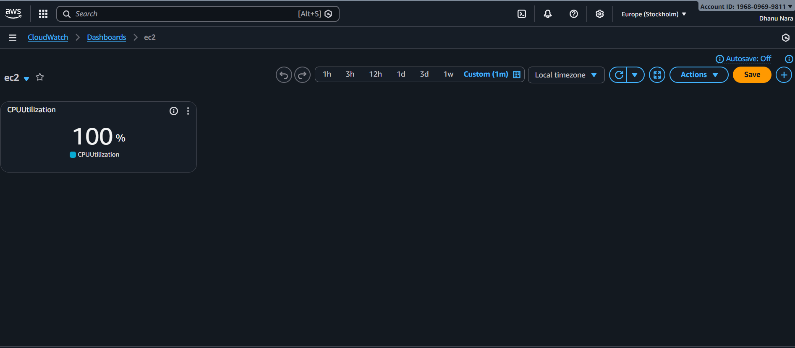

CONCLUSION:
successfully enabled CloudWatch monitoring to collect CPU & other EC2 performance metrics for monitoring and analysis.

4.Create one alarm to send alert to email if the CPU utilization is more than 70 percent.

TITLE:
Alarm to send alert to email

OBJECTIVE:
To trigger an email alert when EC2 CPU Utilization goes above 70%.

PREREQUISITES:
EC2 instance running
SNS topic with email subscription
CloudWatch access
STEP-BY-STEP-IMPLIMENTATION:
Select the metric cpu utilization
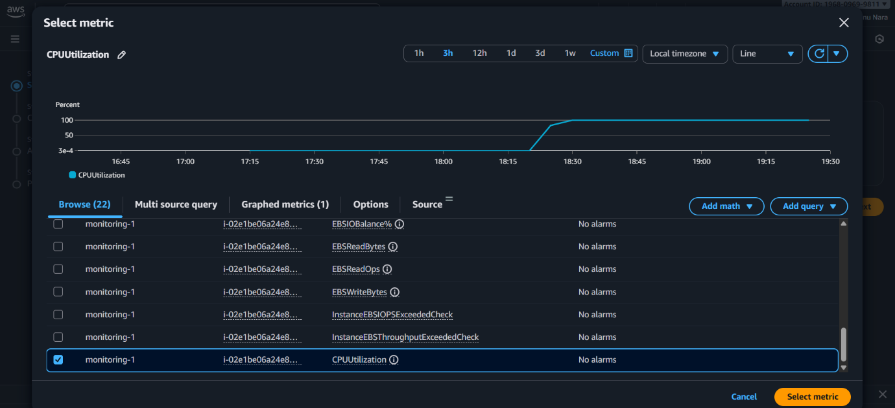
Create an alarm
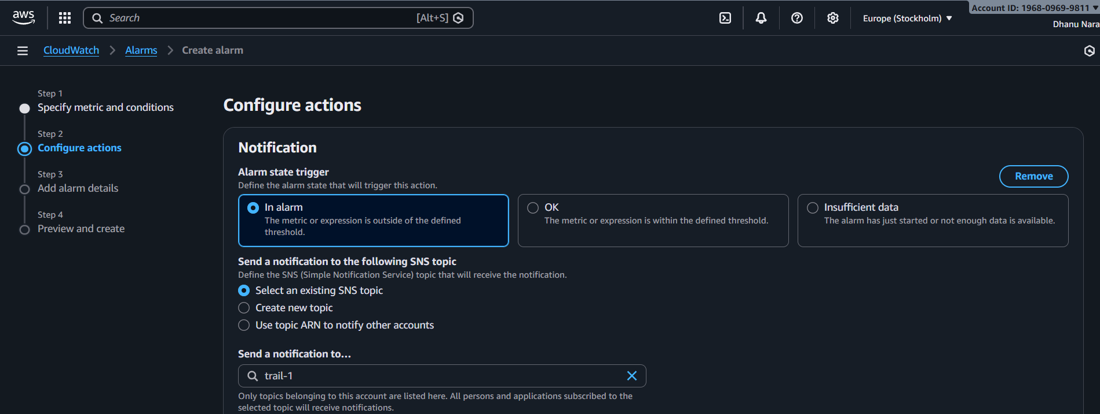
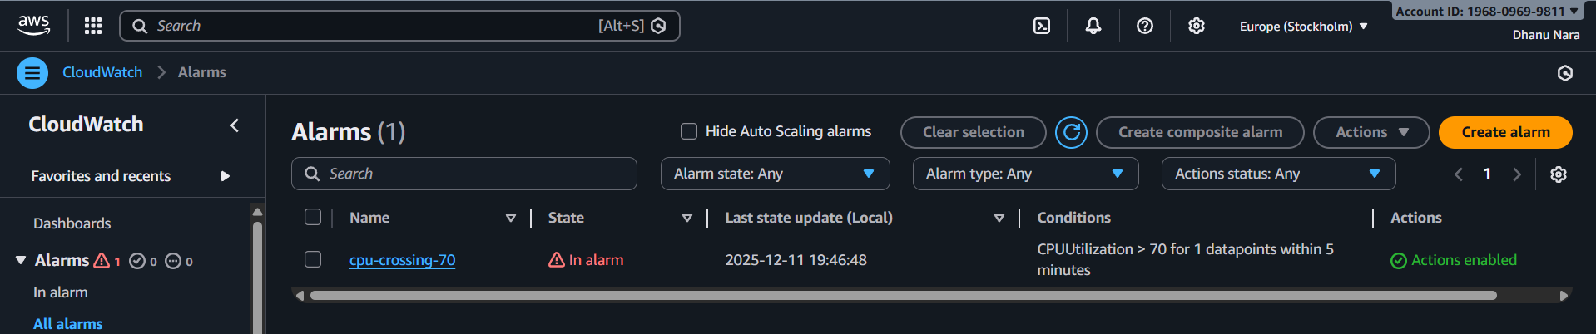
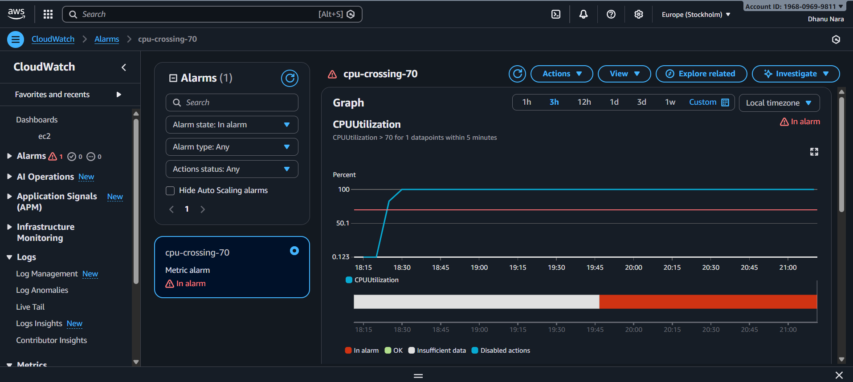
Mail regarding CloudTrail.
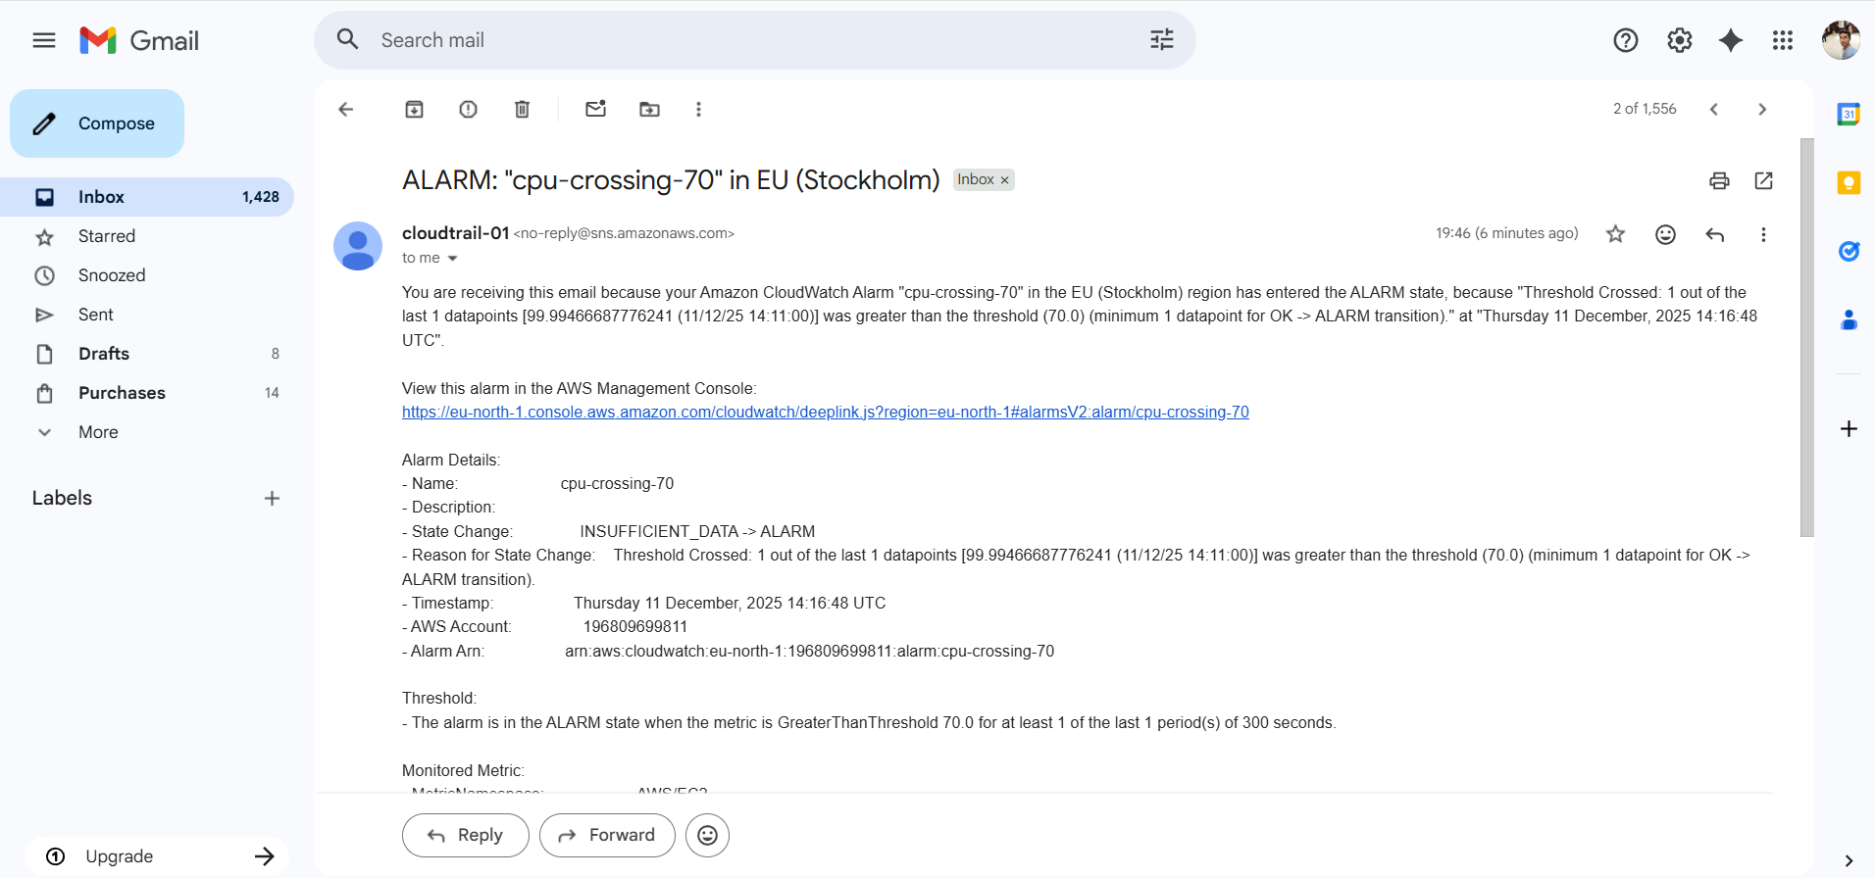

CONCLUSION:
Alarm monitors CPU usage and sends email notification when threshold exceeds.

5.Create Dashboard and monitor tomcat service weather it is running or not and send the alert.
TITLE:
Dashboard to monitor tomcat

OBJECTIVE:
To monitor Tomcat service status on CloudWatch dashboard and send alert when service stops.

PREREQUISITES:
EC2 instance with tomcat installed in it.
CloudWatch agent installed and running on EC2.
SNS Topic and Email subscription confirmed

STEP-BY-STEP-IMPLIMENTATION:
Insatlled tomcat using script.
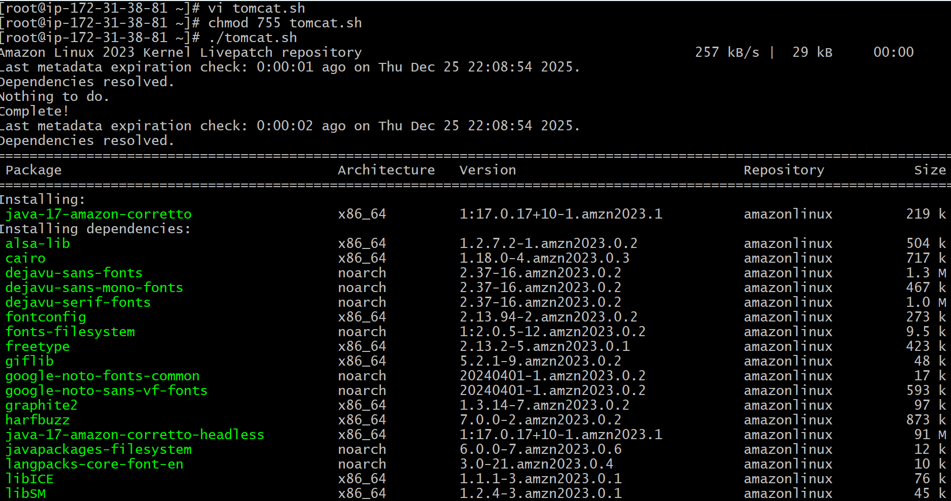
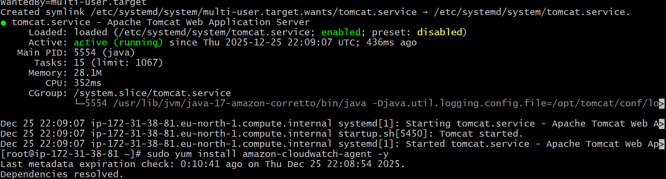
Script created for the tomcat status if it is running value should be 1 . If not value has to be 0.
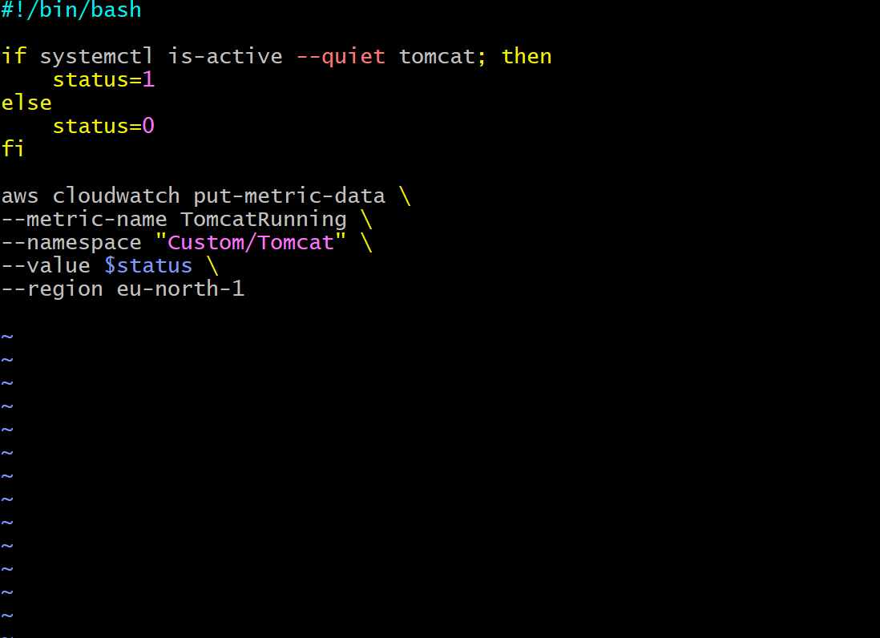
Create dashboard for monitoring.
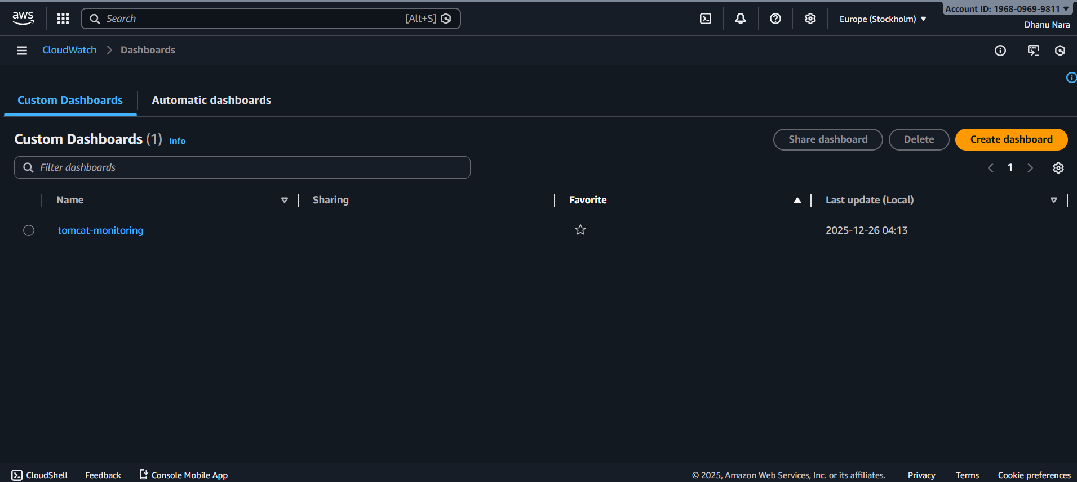
If tomcat is running the value is 1.
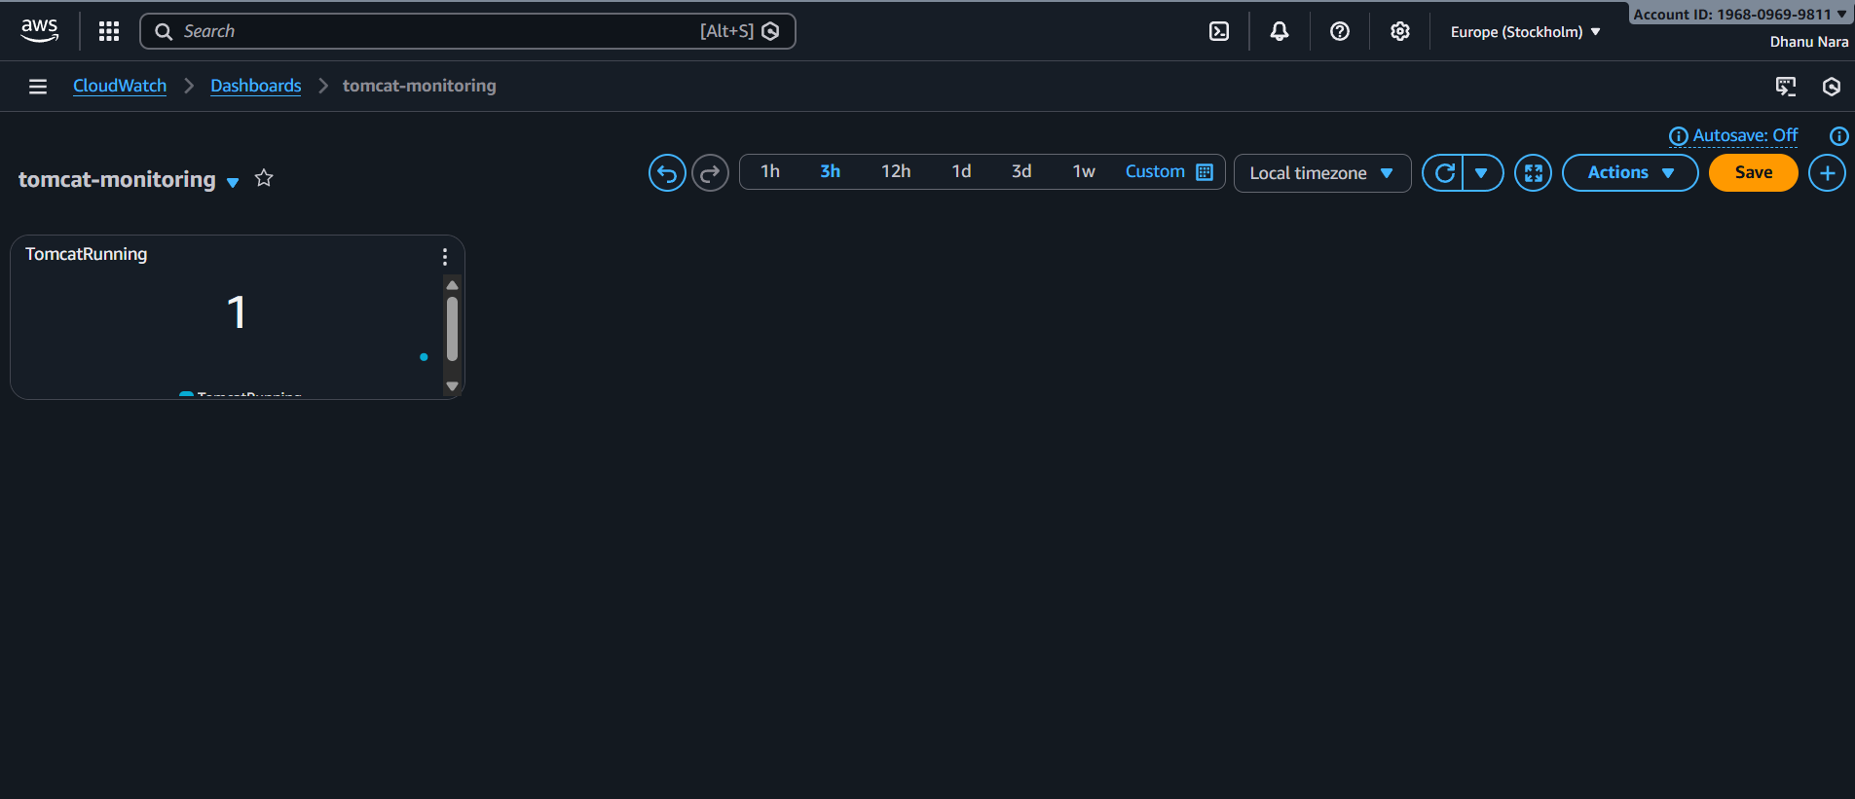
If it is not running value will be 0.
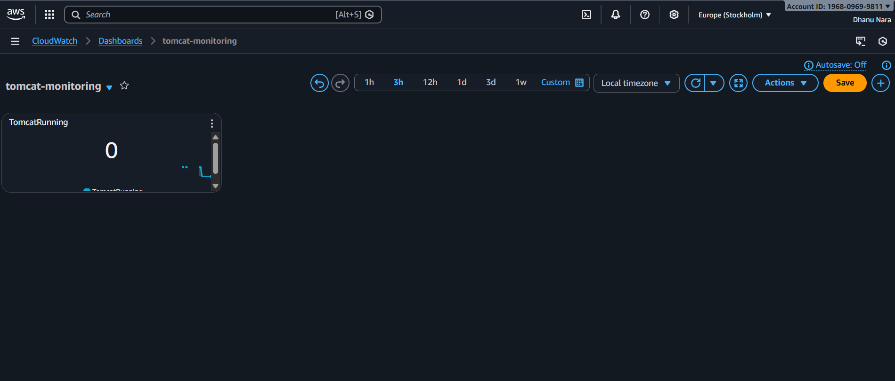
And alarm will be created.
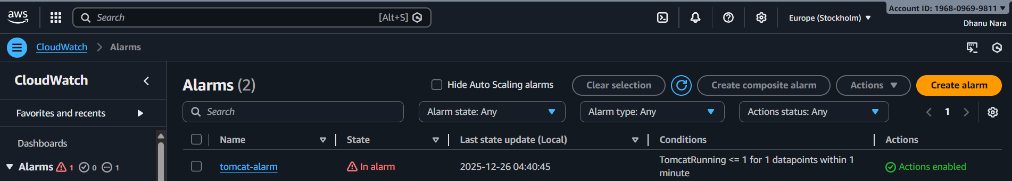
Mail regarding tomcat monitoring.

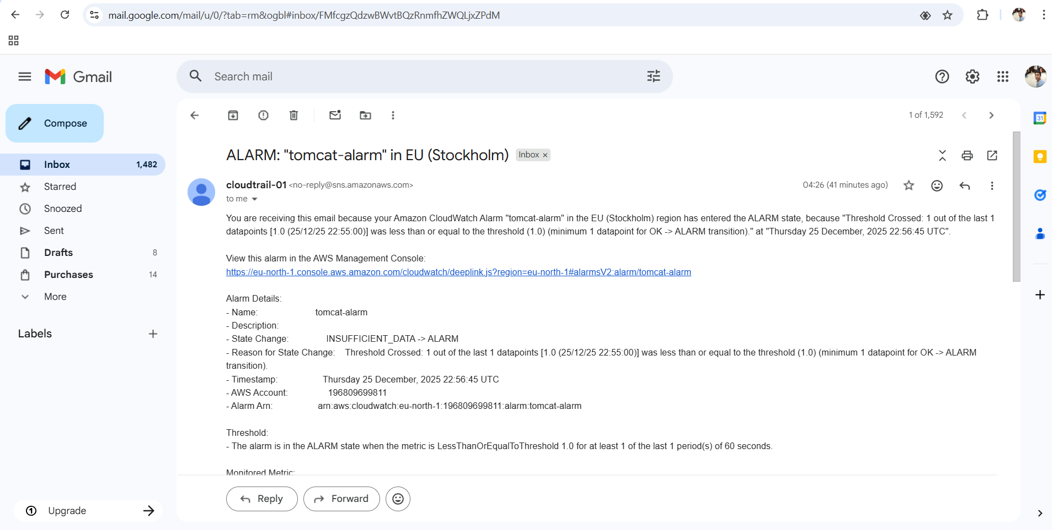

CONCLUSION:
Tomcat service health is visible on the dashboard and triggers email alert if Tomcat stops running.

6.Create Dashboard and monitor nginx service to send the alert if nginx is not running.

TITLE:
Dashboard to monitor nginx

OBJECTIVES:
To monitor Nginx service status on CloudWatch dashboard and send alert if service stops.

PREREQUISITES:
EC2 instance with nginx installed in it
CloudWatch agent configured to collect service status
SNS Topic with email subscription confirmed
STEP-BY-STEP-IMPLIMENTATION:
Installed nginx in ec2
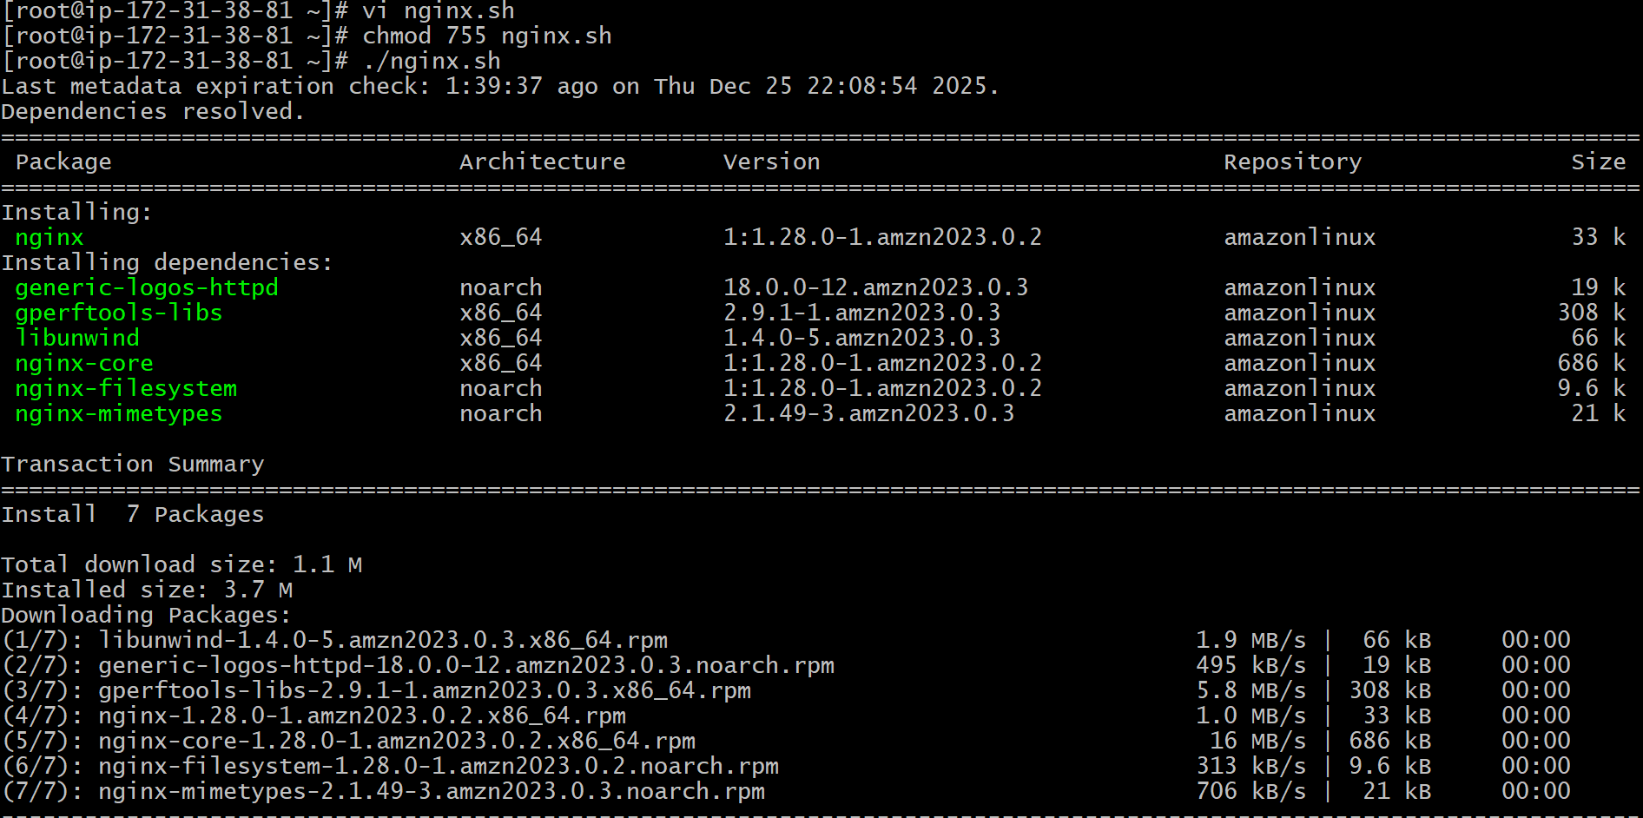
Script to show the value if service running means value has to be 1 or if the service is not running value has to be 0
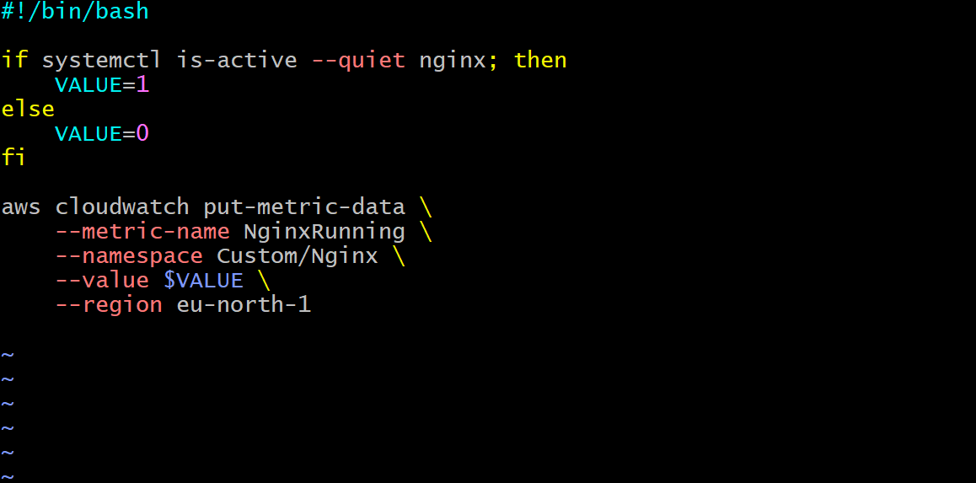
Here the service is running value is 1
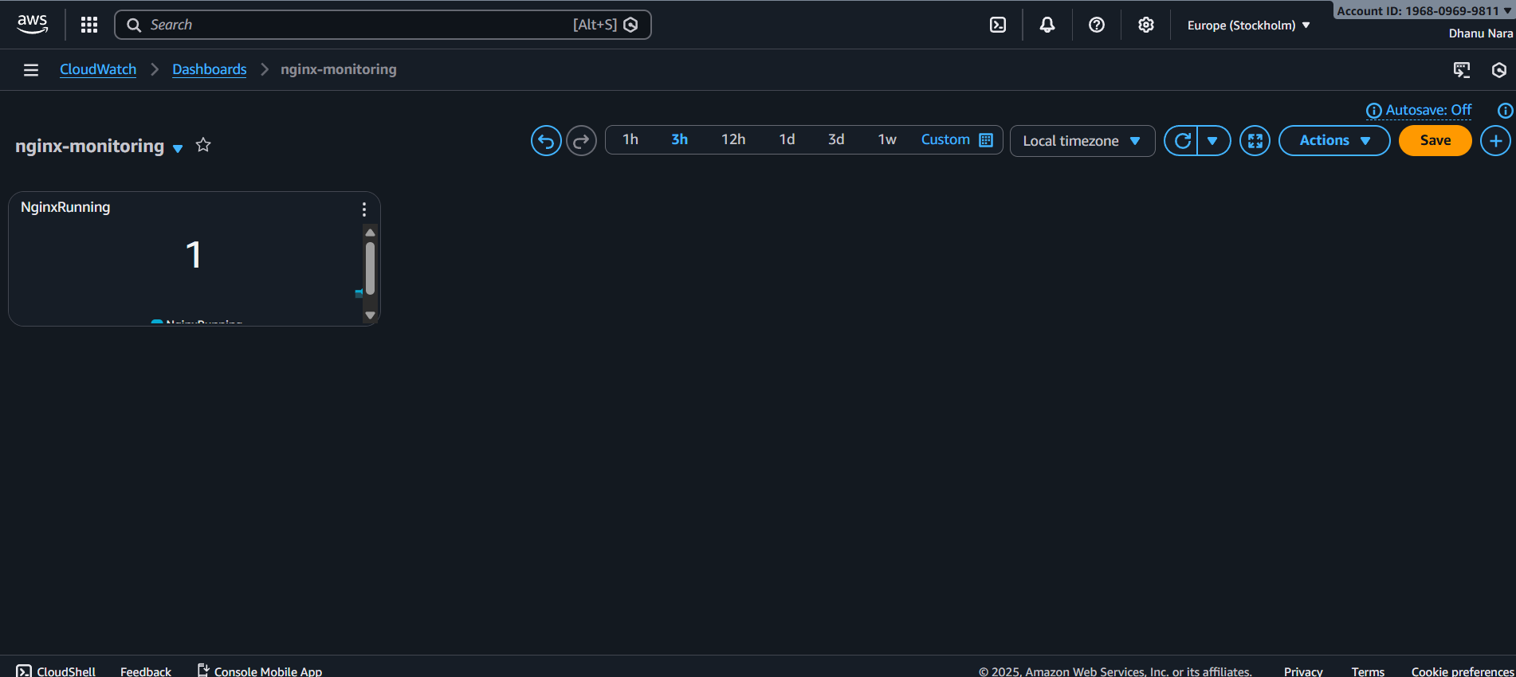
Here the service stopped and the value is 0
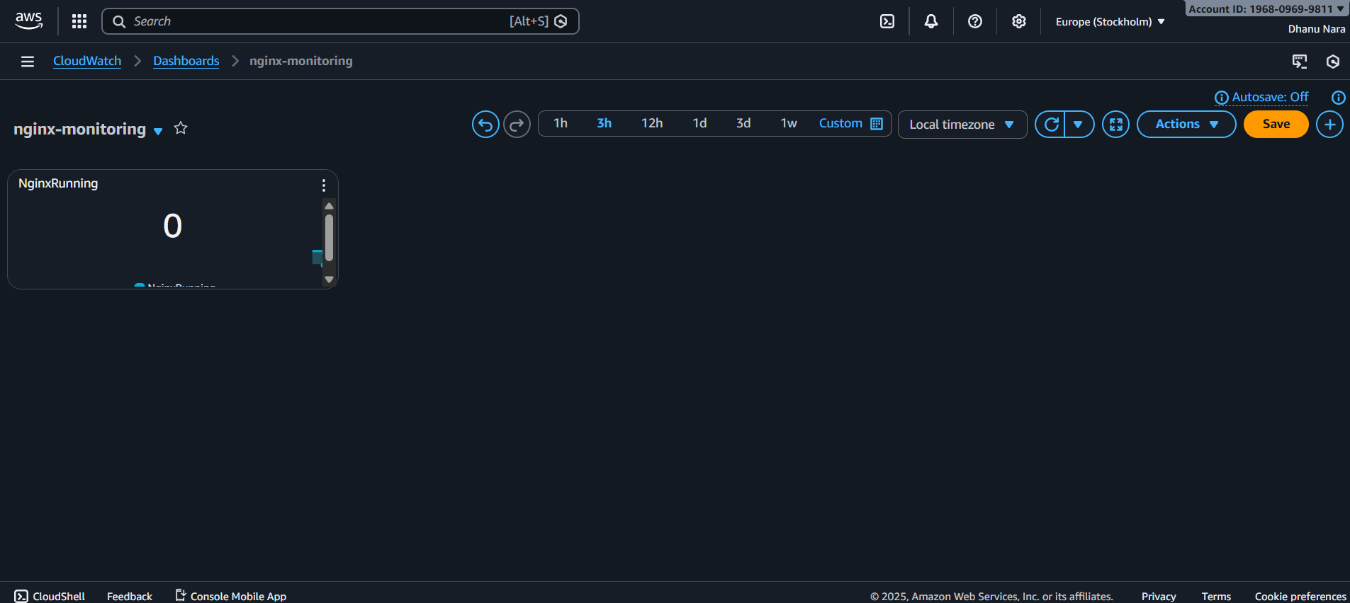
Alarm created
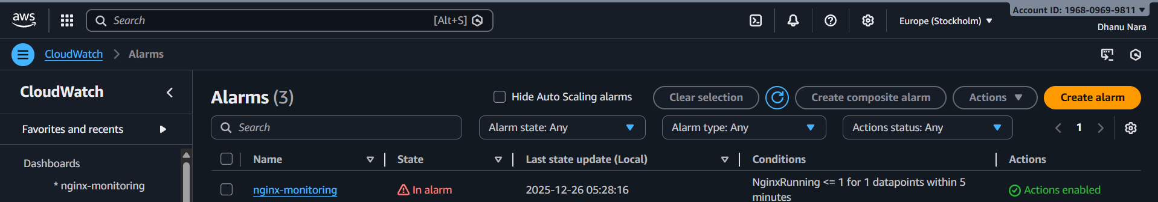

CONCLUSION:
Dashboard monitors Nginx continuously and sends alert when the service is not running.

4.Create one alarm to send alert to email if the CPU utilization and other metrics of ec2.

